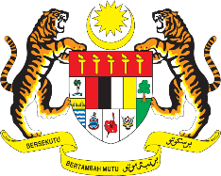

STATEMENT BY MALAYSIA
REVIEW OF MOLDOVA
40TH SESSION OF THE UPR WORKING GROUP
24 JANUARY – 4 FEBRUARY 2022

Malaysia thanks the Republic of Moldova for its national report.

- Malaysia welcomes Moldova’s efforts to advance human rights in the country. We note the various legislative and policy frameworks that have been developed and implemented to promote the well-being and welfare of its people. We hope Moldova would continue to make progress in areas such as rights of minorities and those belonging to vulnerable groups.

- In the spirit of constructive engagement, Malaysia proposes the following recommendations for the consideration of Moldova:

3.1. Continue taking concrete measures to promote the rights of those living with disabilities including by effectively addressing discrimination in the public and private sectors;
3.2. Tackle incidents of hate crimes and hate speech through prompt investigation and ensure perpetrators are prosecuted;
3.3. Step up its efforts to investigate acts of trafficking effectively and to prosecute and punish perpetrators; and
3.4. Tackle discrimination faced by disadvantaged and marginalized individuals and groups.

- Malaysia wishes the Republic of Moldova every success in its UPR undertakings.

Thank you.

28 JANUARY 2022
GENEVA

