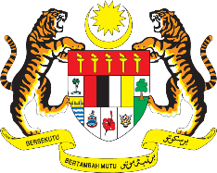

STATEMENT BY MALAYSIA
REVIEW OF THE BOLIVARIAN REPUBLIC OF VENEZUELA
40TH SESSION OF THE UPR WORKING GROUP
24 JANUARY – 4 FEBRUARY 2022

Malaysia thanks Venezuela for its comprehensive presentation of its national report.

- Malaysia is pleased to note key developments in Venezuela in addressing violence against women, including addressing complaints, conducting investigations and providing support for victims of gender-based violence.

- Malaysia proposes the following recommendations for the consideration of Venezuela:

  - Continue implementing its National Human Rights Plan 2016-2019, particularly with regard to the social protection programmes that support women, children and person with disabilities;

  - Continue its efforts in developing a National Plan on business and human rights; and

  - Make further efforts to continue the implementation of training programmes on various human rights issues for public servants.

- We wish Venezuela a successful review.

Thank you.

25 JANUARY 2022
GENEVA

