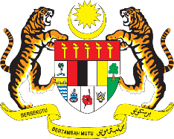

STATEMENT BY MALAYSIA
REVIEW OF SOUTH SUDAN
40TH SESSION OF THE UPR WORKING GROUP
24 JANUARY – 4 FEBRUARY 2022

Malaysia thanks South Sudan for the comprehensive presentation of its national report.

- Malaysia welcomes South Sudan’s efforts in improving its overall human rights situation since its last UPR cycle. Adequate resources and improvement in basic socio-economic and development situation are essential to achieve this goal. As such, we encourage South Sudan to further enhance cooperation with the international community, especially in obtaining technical assistance and capacity-building programmes on various human rights issues.

- In the spirit of constructive engagement, Malaysia proposes the following recommendations for the consideration of South Sudan:

  - Continue its effort to promote and protect the rights of women, children and vulnerable groups; and

  - Continue to implement measures to improve access to education for all.

- We wish South Sudan a successful review.

Thank you.

31 JANUARY 2022
GENEVA

