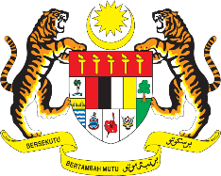

STATEMENT BY MALAYSIA
REVIEW OF LITHUANIA
40TH SESSION OF THE UPR WORKING GROUP
24 JANUARY – 4 FEBRUARY 2022

Malaysia thanks Lithuania for its national report.

- Malaysia commends Lithuania for its commitments to the human rights agenda. We welcome progress in the promotion of rights and welfare of specific groups such as children and women. We note with satisfaction that employment rate among women in Lithuania was the highest within the European Union.

- We hope the Government would continue to empower women including by tackling gender pay gap. We also encourage Lithuania to take steps to further integrate women facing different challenges such as migrant women, older women and women with disabilities into the labour market.

- In the spirit of constructive engagement, Malaysia proposes the following recommendations for the consideration of Lithuania:

4.1. Strengthen efforts to reduce the high pregnancy rate among Roma girls, and ensure the accessibility and availability of sexual and reproductive health education and services and affordable contraception for all women;
4.2. Take further measures to address domestic violence by ensuring thorough and prompt investigation as well as stricter punishment for perpetrators; and
4.3. Provide effective remedies and means of protection for victims of domestic violence

- Malaysia wishes Lithuania every success in its UPR undertakings.

Thank you.

26 JANUARY 2022
GENEVA

