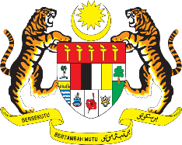

STATEMENT BY MALAYSIA
REVIEW OF ICELAND
40TH SESSION OF THE UPR WORKING GROUP
24 JANUARY – 4 FEBRUARY 2022

Malaysia thanks Iceland for its comprehensive presentation of its national report.

- Malaysia commends Iceland for making progress in the implementation of the recommendations since its previous UPR cycle. We welcome Iceland’s efforts in promoting gender equality through the adoption of the Action Plan for Gender. We are also pleased to note the adoption of the Action Plan on the Prevention of Sexual and Gender-Based Violence to promote preventive measures among children and young people.

- In the spirit of constructive engagement, Malaysia proposes the following recommendations for the consideration of Iceland:

  - Advance the goal to establish a national human rights institution in accordance with the Paris Principles;

  - Continue taking steps in developing a National Action Plan on business and human rights; and

  - Intensify steps to combat and prevent discrimination against persons with disabilities.

- We wish Iceland a successful review.

Thank you.

25 JANUARY 2022
GENEVA

