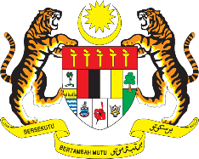

STATEMENT BY MALAYSIA
REVIEW OF HAITI
40TH SESSION OF THE UPR WORKING GROUP
24 JANUARY – 4 FEBRUARY 2022

Malaysia thanks Haiti for its comprehensive presentation of its national report.

- Malaysia welcomes Haiti’s comprehensive strategy to address human trafficking. We congratulate Haiti on the tripartite agreement signed with the Dominican Republic and Jamaica on this matter. Malaysia also commends the development of policies in eliminating gender-based violence and improving the rights of the child.

- In the spirit of constructive engagement, Malaysia proposes the following recommendations for the consideration of Haiti:

  - Continue its efforts towards adopting the National Action Plan on Human Rights;

  - Take concrete steps to improve women’s participation in Parliament; and

  - Take necessary steps to integrate the rights of women and girls with disabilities into gender equality legislation and other relevant policies.

- We wish Haiti a successful review.

Thank you.

31 JANUARY 2022
GENEVA

