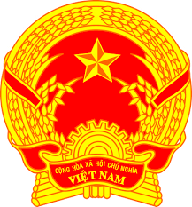
Statement of the Socialist Republic of Viet Nam
At the 40th Session of the UPR Working Group
Review of Zimbabwe
(Geneva, 26 January 2022)

Time: 01 minute and 05 seconds
Mister President,
Viet Nam thanks the delegation of Zimbabwe for the comprehensive presentation of the national UPR report.
Viet Nam welcomes the commitment of Zimbabwe to implementing all the Sustainable Development Goals. Viet Nam takes note of the efforts made by Zimbabwe to promote and protect the rights of women, including measures taken to prevent and respond to violence against women.
In a spirit of constructive dialogue, Viet Nam would like to make the following recommendations to Zimbabwe:
1. Continue its efforts to promote sustainable economic and social development in order to facilitate the enjoyment of human rights of its people.
2. Continue its efforts to end child marriages.
Viet Nam wishes Zimbabwe a successful review.
Thank you, Mister President./.

