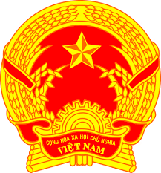
Statement of the Socialist Republic of Viet Nam
At the 40th Session of the UPR Working Group
Review of Togo
(Geneva, 24 January 2022, 09:00 – 12:30)

Mister President,
Viet Nam warmly welcomes the delegation of Togo and thanks them for the presentation of the national UPR report.
Viet Nam acknowledges the efforts of Togo to strengthen the legal and institutional framework for the promotion and protection of human rights and effectively ensure the exercise of human rights in the country, especially during the COVID-19 pandemic.
We also appreciate Togo’s national initiatives to promote gender equality and reduce poverty such as the two national programmes on women’s empowerment in the political and professional spheres.
Given the progress that has been made, Viet Nam therefore makes the following two recommendations to Togo:
First, continue the implementation of measures aimed at reducing poverty and improving educational outcomes for children;
Second, continue to promote gender equality, combat sexual and gender-based violence and step up policies aimed at reducing disparities between men and women.
Finally, we wish Togo a successful review outcome.
I thank you, Mister President./.

