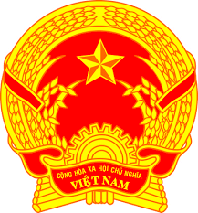
Statement of the Socialist Republic of Viet Nam
At the 40th Session of the UPR Working Group
Review of Timor-Leste
(Geneva, 27 January 2022, 14:30 – 18:00)

Mister President,
Viet Nam warmly welcomes the delegation of Timor-Leste and thanks them for their national UPR report.
We appreciate Timor-Leste’s concrete policies, programmes and measures for the promotion and protection of human rights, particularly the rights of
vulnerable groups and economic, social and cultural rights. Besides, Viet Nam commends Timor-Leste's strong commitment to socio-economic development for the better enjoyment of human rights by its people.
In the spirit of constructive dialogue, Viet Nam has two recommendations for Timor-Leste:
1. Enhance efforts, including allocating more resources, to implement the national action plan for the promotion of the rights of persons with disabilities for 2021-2030, guided by the CRPD.
2. Take further steps to promote the enjoyment of human rights by vulnerable groups, especially in elaborating and implementing national plan for inclusive recovery from the COVID-19 pandemic.
Finally, we wish Timor-Leste every success in this UPR cycle.
I thank you, Mister President.

