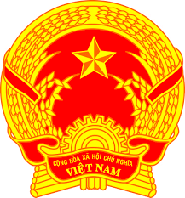
Statement of the Socialist Republic of Viet Nam
At the 40th Session of the UPR Working Group
Review of the Syrian Arab Republic
(Geneva, 24 January 2022, 14:30 – 18:00)

Mister President,
Viet Nam warmly welcomes the delegation of the Syrian Arab Republic and thanks them for their UPR report.
We noted the efforts of the Government of Syria in addressing numerous challenges to peace, stability and development, particularly the promotion and protection of human rights in the country.
With a view to fostering national reconciliation and inclusive human rights in the country, Viet Nam makes two recommendations to Syria at this UPR review:
1. Enhance measures for national and international coordination to better facilitate humanitarian and development assistance particularly in conflict areas.
2. Provide women with every opportunity to contribute fully and effectively to political, economic, social and cultural life, including the national reconciliation process.
Finally, we wish Syria a successful review outcome.
I thank you, Mister President./.

