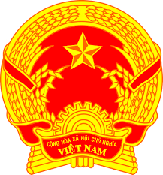
Statement of the Socialist Republic of Viet Nam
At the 40th Session of the UPR Working Group
Review of Sudan
(Geneva, 09 February 2022)

Time: 01 minute and 05 seconds

Mister President,
Viet Nam thanks the delegation of Sudan for the comprehensive presentation of the national UPR report.
Viet Nam takes note of the efforts of Sudan in the implementation of the recommendations accepted under the 2nd UPR cycle.
In a spirit of constructive dialogue, Viet Nam would like to make the following recommendations to Sudan:
1. Make its efforts to promote peace and security in order to facilitate the enjoyment of human rights of its people.
2. Continue its efforts to promote and protect the rights of migrants, refugees, asylum seekers, displaced persons and to combat human trafficking.
Viet Nam wishes Sudan a successful review.
Thank you, Mister President./.

