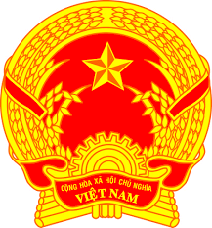
Statement of the Socialist Republic of Viet Nam
At the 40th Session of the UPR Working Group
Review of the Bolivarian Republic of Venezuela
(Geneva, 25 January 2022, 14:30 – 18:00)

Mister President,
Viet Nam warmly welcomes the delegation of Venezuela and thanks them for their national UPR report.
We appreciate various measures taken by Venezuela to implement recommendations since the adoption of its second UPR report despite the challenging socio-economic situation in the country.
In the spirit of constructive engagement, my delegation proposes two recommendations to Venezuela:
One, continue to expand its legal framework for the promotion and protection of human rights, the rights of women, especially with regard to gender-based violence.
Two, continue the cooperation with United Nations human rights mechanisms and treaty bodies.
In conclusion, we wish the delegation of Venezuela a very successful UPR process.
I thank you, Mister President./.

