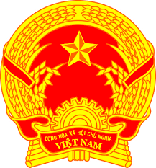
Statement of the Socialist Republic of Viet Nam
At the 40th Session of the UPR Working Group
Review of Iceland
(Geneva, 25 January 2022, 09:00 – 12:30)

Mister President,
Viet Nam welcomes the distinguished delegation of Iceland and thanks them for the comprehensive presentation.
We appreciate the high standards of human rights in Iceland and note with appreciation that Iceland is a party to numerous major human rights instruments. Thus, Viet Nam would like to recommend the following to Iceland:
- Keep up the work on the ratification of the International Convention for the Protection of All Persons from Enforced Disappearance.
- Consider to ratify the Optional Protocol to the Convention on the Rights of Person with Disabilities.
- Continue its proactive efforts in order to ensure full gender equality in education and the labour market as well as share best practices in this field.
To conclude, we wish Iceland success in this UPR cycle.
I thank you, Mister President./.

