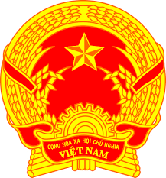
Statement of the Socialist Republic of Viet Nam
At the 40th Session of the UPR Working Group
Review of Haiti
(Geneva, 31 January 2022)

Time: 01 minute and 20 seconds
Mister President,
Viet Nam thanks the delegation of Haiti for the comprehensive presentation of the national UPR report.
Viet Nam welcomes the efforts of the Government of Haiti to work for the promotion and protection of human rights and in its implementation of the recommendations accepted under the 2nd UPR cycle.
In a spirit of constructive dialogue, Viet Nam would like to make the following recommendations to Haiti:
1. Continue its efforts to promote security and stability in order to facilitate the enjoyment of human rights of its people.
2. Continue its efforts to promote and protect the rights of persons with disabilities, including integrating the rights of women and girls with disabilities into the gender equality legislation as well as into laws and policies on disability.
Viet Nam wishes Haiti a successful review.
Thank you, Mister President./.

