[Check against delivery]

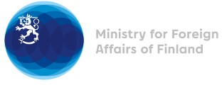

40 Session of the UPR working group Recommendations by Finland to Uganda

27 January 2022

Finland welcomes the engagement of Uganda in the UPR. We commend Uganda as one of the first countries in Africa for adopting a National Action Plan on Business and Human Rights anchored on the United Nations Guiding Principles on Business and Human Rights. Finland recommends the following:

- Firstly, to implement existing legislation protecting children against exploitation, even under the conditions of the COVID-19 pandemic; including ensuring access to education for all children, protection against sexual harassment, protection from all forms of violence and protection against child labour,

- Secondly, to ensure freedom of expression, association and peaceful assembly and that representatives and supporters of political parties, the media and the civil society are not restricted from exercising these rights,

- Thirdly, to amend the Sexual Offences Act 2021 to ensure that it is compliant with international human rights standards.

Thank you.

