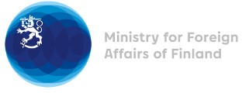

40 Session of the UPR working group Recommendations by Finland to Togo

24 January 2022

Finland highly appreciates the engagement of Togo in the UPR process and commends the efforts made to increase women’s participation in politics, as well as the organisation of municipal elections in 2019 for the first time in 37 years. Finland wishes to recommend the following:

- Firstly, to issue a standing invitation to the UN Special Procedures, including accepting a visit from the Special Rapporteur on the right to peaceful assembly and freedom of association,
- Secondly, to ratify the Optional Protocol to the Convention on the Elimination of All Forms of Discrimination against Women.

I thank you.

