[Check against delivery]

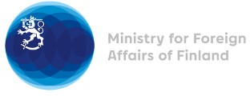

40th Session of the UPR working group Recommendations by Finland to Sudan

1.2.2022

Finland strongly condemns the violence against peaceful protesters and medical and humanitarian personnel in Sudan. This must stop immediately.

Finland welcomes the engagement of the Republic of the Sudan in the UPR process and wishes to recommend the following:

- Firstly, to respect freedom of expression, association and peaceful assembly, to ensure a prompt, independent and impartial investigation into all human rights violations, and to hold those responsible to account.

- Secondly, to continue legal reforms pursued by the transitional government under PM Hamdok, including criminalization of female genital mutilation, and to ensure their full implementation.

Finland urges the Republic of the Sudan to return to the path of democratic transition, based on the 2019 Constitutional Declaration. This is the best guarantee for the long-term stability of the country. Finland continues to support those working for a democratic Sudan with a fully legitimate civilian government ensuring peace, freedom and justice for the Sudanese people.

Thank you.

