[Check against delivery]

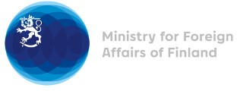

40th Session of the UPR working group Recommendations by Finland to Moldova

28 January 2022

Finland highly appreciates the engagement of the Republic of Moldova in the UPR process. Finland congratulates Moldova on ratifying the Istanbul Convention. This is an important step forward in eliminating all forms of gender-based violence
Finland wishes to recommend the following:

- Firstly, to implement the Istanbul Convention and to take measures to ensure access to justice and legal aid for victims of domestic and sexual violence and develop specialised services for women survivors of violence.

- Secondly, to continue efforts to ensure the right of persons with disabilities to live independently through enhancing implementation of the national action plans for deinstitutionalization and social inclusion of persons with disabilities, including development of alternative community-based social services and improving accessibility and access to assisting technologies.

Finland also encourages the Republic of Moldova to continue to address the capacities of the Equality Council by strengthening the mandate of the Council.

Thank you.

