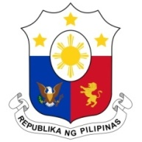
PHILIPPINES

HUMAN RIGHTS COUNCIL
40th Session of the Working Group on the Universal Periodic Review
24 January 2022, Palais des Nations, Geneva, Switzerland

TOGO

Speaking Time: 1 minute and 10 seconds
Speaking Order: 32nd of 95

Thank you, Chair.

The Philippines welcomes the delegation of Togo and thanks it for the presentation of its national report.

We welcome the measures undertaken by Togo to further promote gender equality and advance women’s rights and economic empowerment. We are pleased to note the programs pursued with regard to human rights education and training and commend Togo on its ratification of the ICRMW in 2020.

In a constructive spirit, the Philippines presents the following recommendations for consideration by Togo:

- Ensure the provision of adequate resources to support the work of the National Commission to Combat Trafficking in Persons;

- Redouble its efforts in awareness-raising campaigns and capacity-building for duty bearers to combat child trafficking and child labor, especially the worst forms of child labor; and

- Further strengthen protection measures for women against all forms of violence including domestic violence.

We wish Togo every success in this review cycle.

Thank you, Chair. END.

