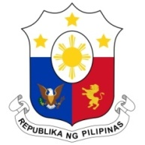
PHILIPPINES

HUMAN RIGHTS COUNCIL
40th Session of the Working Group on the Universal Periodic Review
24 January 2022, Palais des Nations, Geneva, Switzerland

SYRIAN ARAB REPUBLIC

Speaking Time: 1 minute and 10 seconds
Speaking Order: 85th of 96

Thank you, Chair.

The Philippines welcomes the delegation of the Syrian Arab Republic and thanks it for the presentation of its national report.

We recognize the constructive approach of Syria to the UPR process and express our appreciation for the support it rendered in the repatriation of Filipino victims of trafficking and in the filing of cases against the perpetrators.

In a constructive spirit, the Philippines presents the following recommendations for consideration by the Syrian Arab Republic:

- Continue to enhance assistance to victims of trafficking and strengthen its inclusive and multi-stakeholder approach to combating trafficking in persons; and

- Take further steps to address violence against women and children including by ensuring the provision of accessible and adequate support services for victims.

We wish the Syrian Arab Republic every success in this review cycle.

Thank you, Chair. END
.

