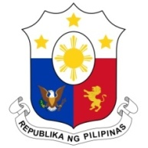
PHILIPPINES

HUMAN RIGHTS COUNCIL
40th Session of the Working Group on the Universal Periodic Review
1 February 2022, Palais des Nations, Geneva, Switzerland

REPUBLIC OF THE SUDAN

Speaking Time: 1 minute and 5 seconds
Speaking Order: 30th of 107

Thank you, Chair.

The Philippines welcomes the delegation of Sudan to this UPR cycle.

We acknowledge the commitment of the Sudan to further advance human rights in the country, especially of the vulnerable groups.

We welcome its national strategies and plans in the areas of sustainable development and its efforts to align legislative measures with international obligations.

In a constructive spirit, the Philippines presents the following recommendations:

- Consider strengthening data collection and management related to gender equality and women’s human rights;

- Intensify capacity-building efforts for duty bearers in the field of anti-trafficking in persons; and

- Ensure the protection of children from grave violations and the provision of adequate support for their reintegration and rehabilitation.

We wish the Sudan every success in this review cycle.

Thank you, Chair. END.

