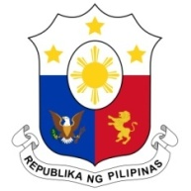
PHILIPPINES

HUMAN RIGHTS COUNCIL
40th Session of the Working Group on the Universal Periodic Review
28 January 2022, Palais des Nations, Geneva, Switzerland

REPUBLIC OF MOLDOVA

Speaking Time: 1 minute and 30 seconds
Speaking Order: 62nd of 76

Thank you, Chair.

The Philippines welcomes the delegation of Moldova and thanks it for the presentation of its national report.

We acknowledge Moldova’s adoption of its National Human Rights Action Plan 2018 to 2022 in line with the recommendations presented in the second UPR cycle. We also welcome the accreditation of the Office of the People’s Advocate by the GANHRI as compliant with the Paris Principles.

In a constructive spirit, the Philippines presents the following recommendations for consideration by Moldova:

- Take steps to support greater participation and representation of women in public and political affairs;

- Ensure the allocation of sufficient resources for protection and support services for victims of trafficking in persons especially women and children;

- Consider ratifying the ICRMW.

We wish Moldova every success in this review cycle.

Thank you, Chair. END.

