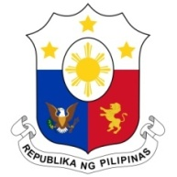
PHILIPPINES

HUMAN RIGHTS COUNCIL
40th Session of the Working Group on the Universal Periodic Review
25 January 2022, Palais des Nations, Geneva, Switzerland

BOLIVARIAN REPUBLIC OF VENEZUELA

Speaking Time: 55 seconds
Speaking Order: 112th of 119

Thank you, Chair.

The Philippines welcomes the delegation of Venezuela and thanks it for the presentation of its national report.

My delegation acknowledges the efforts of Venezuela to implement the accepted recommendations during its second cycle UPR, in particular on the protection of the rights of women and children.

In a constructive spirit, the Philippines presents the following recommendations for consideration by Venezuela:

- Further strengthen the implementation of national poverty reduction measures with the conduct of inclusive periodic assessments;

- Strengthen programs on women’s economic empowerment including on enhancing their access to credit and financial services and technical and vocational education and training; and

- Redouble its efforts in conducting training programs for duty bearers to enhance identification and referral of victims of trafficking in persons especially women and children.

We wish Venezuela every success in this review cycle.

Thank you, Chair. END.

