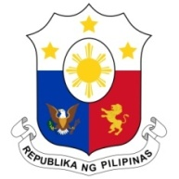
PHILIPPINES

HUMAN RIGHTS COUNCIL
40th Session of the Working Group on the Universal Periodic Review
31 January 2022, Palais des Nations, Geneva, Switzerland

SOUTH SUDAN

Speaking Time: 1 minute and 15 seconds
Speaking Order: 34th of 93

Thank you, Chair.

The Philippines welcomes the delegation of South Sudan to this UPR cycle.

We acknowledge the efforts made by South Sudan in implementing the recommendations received from the previous UPR cycle.

We also recognize its efforts in the areas of institution building and strengthening including through technical assistance and capacity-building programs with development partners.

In a constructive spirit, the Philippines presents the following recommendations for consideration by South Sudan:

- Ensure the allocation of adequate resources towards socio-economic development programs including on poverty alleviation;

- Take effective and comprehensive measures to improve nutrition and food security situation; and

- Continue to strengthen prevention and protection measures against sexual and gender-based violence including through fostering greater multi-sectoral partnerships.

We wish South Sudan every success in this review cycle.

Thank you, Chair. END.

