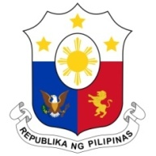
PHILIPPINES

HUMAN RIGHTS COUNCIL
40th Session of the Working Group on the Universal Periodic Review
26 January 2022, Palais des Nations, Geneva, Switzerland

LITHUANIA

Speaking Time: 1 minute and 20 seconds
Speaking Order: 78th of 85

Thank you, Chair.

The Philippines welcomes the delegation of Lithuania and thanks it for the presentation of its national report.

My delegation welcomes the accreditation of Seimas Ombudsman Office as Lithuania’s NHRI under the Paris Principles with “A” status. We also acknowledge the further steps taken to combat trafficking in persons and promote the participation of women in the public sphere.

In a constructive spirit, the Philippines presents the following recommendations for consideration by Lithuania:

- Step up efforts in conducting gender sensitivity training for duty bearers in handling cases of trafficking in persons;

- Further strengthen measures to prevent gender-based violence including domestic violence and ensure the accessibility of support services for victims.

- Consider ratifying the ICRMW.

We wish Lithuania every success in this review cycle.

Thank you, Chair. END.

