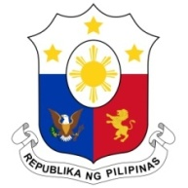
PHILIPPINES

HUMAN RIGHTS COUNCIL
40th Session of the Working Group on the Universal Periodic Review
31 January 2022, Palais des Nations, Geneva, Switzerland

HAITI

Speaking Time: 1 minute and 20 seconds
Speaking Order: 32nd of 87

Thank you, Chair.

The Philippines welcomes the delegation of Haiti to this UPR cycle.

We acknowledge the constructive approach of Haiti to the UPR process. We welcome the steps taken to advance social protection and to eliminate the worst forms of child labor.

In a constructive spirit, the Philippines presents the following recommendations for consideration by Haiti:

- Further strengthen investigation and prosecution of cases of trafficking in persons, especially women and children; and

- Ensure the integration of gender-sensitive, inclusive, and participatory approaches in disaster risk reduction and climate change adaptation planning processes.

We wish Haiti every success in this review cycle.

Thank you, Chair. END.

