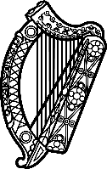

Statement of Ireland
40th session of the UPR Working Group

Review of the Syrian Arab Republic

[24 January 2022]

Ireland welcomes the delegation of the Syrian Arab Republic.

We deeply regret that the human rights situation for many Syrians continues to deteriorate.

Ireland calls for full access to international monitors, including the Independent International Committee of Inquiry.

Ireland recommends:

- Disclose and investigate all deaths in custody since 2011.
- Release those arbitrarily deprived of their liberty and allow independent humanitarian organisations, including the International Committee of the Red Cross (ICRC), unconditional access to all formal, informal and secret detention facilities.
- Protect Housing, Land, and Property rights in accordance with national and international law by re-issuing destroyed or lost property documents and recognising alternative forms of proof.

We wish the Syrian Arab Republic success in this UPR cycle. Thank you.

