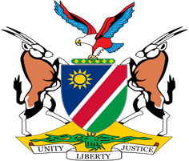

Statement by H.E. Julia Imene-Chanduru, Ambassador/Permanent Representative, UPR of the Republic of Zimbabwe, 26 January 2022

Thank you, Mr. President,

Namibia warmly welcomes the Esteemed delegation from the sisterly Republic of Zimbabwe and thank them for submitting a comprehensive national report as well as their commitment to the UPR process.

Mr. President,

The Universal Periodic Review is not only an opportunity to make recommendations, but it is also an opportunity to highlight some of the factors that negatively impact human rights in specific countries. As neighbours of our brothers and sisters in Zimbabwe we have witnessed first hand over the years the negative impact on socio-economic rights of the illegal sanctions imposed on Zimbabwe. We again call on the sanctioning countries to immediately remove these sanctions.

In the spirit of constructive dialogue we make the following recommendations for consideration by Zimbabwe:

1. Ratify the Optional Protocol to Convention on Elimination of All Forms of Discrimination against Women;

2.Ratify the Convention against Torture and other Cruel, Inhuman or Degrading Treatment or Punishment

We wish the delegation of Zimbabwe a successful review.

I thank you Mr. President.

