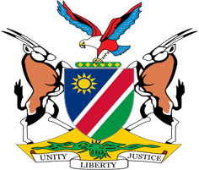

Statement by Jerry Mika, UPR of the Republic of Uganda, 27 January 2022

Thank you Mr. President,

Namibia warmly welcomes the Esteemed Delegation of Uganda to the Third Cycle Universal Periodic Review.

Having read the national report we are pleased, notwithstanding the difficult past, with the progress made by Uganda to improve human rights of all persons on its territory. Uganda should particularly be applauded for her humanitarian efforts, being the largest host of Refugees in Africa and the third in the world.

In the spirit of constructive dialogue we make the following recommendations for consideration by Uganda:

1. Expedite the process of adopting and enacting the divorce and marriage bill;

2. Ratify the International Labour Organisation's Domestic Workers Convention (No. 189 of 2011)

We wish the delegation of Uganda a successful review.

I thank you Mr. President.

