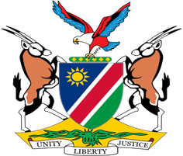

Statement by Tangi Shikongo, UPR of the Republic of Togo, 24 January 2022

Thank you, Mr. President,

Namibia warmly welcomes the Esteemed delegation of the Republic of Togo to the Third Cycle UPR and thank them for submitting a comprehensive national report.

We commend Togo for the positive human rights impact measures taken during the period under review which include the adoption of term limits for the President and other office bearers, aimed at strengthening governance and democracy in the Togolese Republic.

In the spirit of constructive dialogue, we make the following recommendations for consideration by Togo:

1. Ratify the Optional Protocol to the Convention on the Elimination of All Forms of Discrimination against Women;

2. Ratify the International Labour Organisation's Domestic Workers Convention (No. 189 of 2011)

We wish the delegation of Togo a successful review.

I thank you Mr. President.

