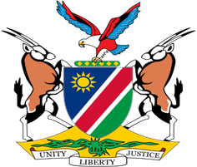

Statement by Tangi Shikongo, UPR of Timor Leste, 27 January 2022

Thank You Mr. President,

- Namibia welcomes the esteemed delegation of Timor Leste and we thank them for their commitment to the UPR process.

- Namibia commends the ongoing efforts of the Government of Timor Leste aimed at improving human rights in their country. We particularly note the measures taken during the period under review to promote and protect the rights of women, children, and persons with disabilities. We also applaud the domestic measures taken by Timor Leste to prevent and punish the most serious international crimes such as genocide and crimes against humanity.

- While commending these positive human rights impacting measures, we wish to note that there is room for improvement and in the spirit of constructive dialogue we make the following recommendations for consideration by Timor Leste:

      - Ratify the Convention on the Rights of Persons with Disabilities;
      - Develop a National Action Plan for the Protection and Promotion of Human Rights

- We wish the delegation of Timor Leste a successful review.

I thank you Mr. President.

