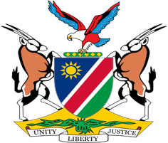

Statement by Tangi Shikongo, UPR of the Syrian Arab Republic, 24 January 2022

Thank you, Mr. President,

Namibia warmly welcomes the Esteemed Delegation of the Syrian Arab Republic and thank them for their commitment to the UPR process.

The ongoing conflict in Syria continues to have a negative impact on human rights in that Country. In this regard we note the Syrian Government's concerns about the sale of weapons to various armed groups in Syria and we therefore call on States to put measures in place to prevent the sale and supply of weapons to armed groups in Syria. We are encouraged by the Syrian Government's efforts to address the problem of mines and other explosive devices but remain extremely concerned about their use by terrorist organizations and the Israeli Occupation authorities in Syria.

In the spirit of constructive dialogue, we make the following recommendations for consideration by Syria:

1. Ratify the 1951 Convention relating to the Status of Refugees and its 1967 Protocol;
2. Ratify the Anti-Personnel Mine Ban Convention

We wish the delegation of Syria a successful review.
I thank you Mr. President.

