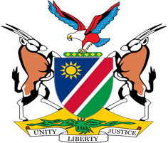

Statement by Jerry Mika, UPR of the Republic of Sudan, 01 February 2022

Thank you Mr. President,

Namibia warmly welcomes the Esteemed Delegation of Sudan to the Third Cycle Universal Cycle Universal Periodic Review and thank them for submitting a comprehensive national report which sets out the measures taken by Sudan to implement the recommendations it received during its last review.

We are pleased to note that, notwithstanding the recent challenges, Sudan has recorded progress in its efforts to protect the human rights of all persons on its territory. This includes legislative amendments to increase the penalty for offences involving the trafficking of women and children and the ratification of some core international human rights treaties.

There, however, remains room for improvement and in the spirit of constructive dialogue, Namibia makes the following recommendations for consideration by Sudan:

1. Ratify the Optional Protocol to the Convention on the Elimination of All Forms of Discrimination against Women;

2. Ratify the Second Optional Protocol to the International Covenant on Civil and Political Rights aiming to the abolition of the death penalty

We wish the delegation of the Sudan a successful review.

I thank you Mr. President

