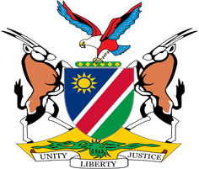

Statement by H.E. Julia Imene-Chanduru, Ambassador/Permanent Representative, UPR of the Bolivarian Republic of Venezuela, 25 January 2022

Thank you, Mr. President,

Namibia warmly welcomes the esteemed delegation of Venezuela, led by Her Excellency Delcy Rodriguez, Executive Vice-President of Venezuela, to the Third Cycle Universal Periodic Review.

While taking note of the positive human rights impact measures taken by Venezuela during the period under review, we again deplore the illegal sanctions imposed on Venezuela and reiterate our call for their immediate removal given their negative impact on the enjoyment of human rights in Venezuela.

In the spirit of constructive dialogue, we make the following recommendations for consideration by Venezuela:

1. Accede to the 1951 Convention relating to the Status of Refugees;

2. Develop a national action plan to comprehensively address gender-based violence and other forms of violence against women.

We wish the delegation of Venezuela a successful review.

I thank you Mr. President.

