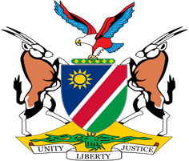

Statement by Jerry Mika, UPR of the Republic of South Sudan, 31 January 2022

Thank you Mr. President,

Namibia warmly welcomes the esteemed delegation to Third Cycle Cycle Universal Periodic Review and the second review of South Sudan since it gained independence in 2011.

Namibia has taken note of progress made in the implementation of the recommendations South Sudan accepted during its first review in 2016. We are particularly pleased to note that South Sudan is committed to fully cooperate with all human rights mechanisms and commend the Government for facilitating unrestricted access into the territory of South Sudan by various UN and AU delegations since its last review in 2016.

Namibia makes the following recommendations for consideration by South Sudan:
1. Accede to the International Covenant on Civil and Political Rights and the International Covenant on Economic, Social and Cultural Rights;

2. Ratify the Protocol to the African Charter on Human and Peoples Rights on the Rights of Women in Africa

We wish the delegation of South Sudan a successful review.

