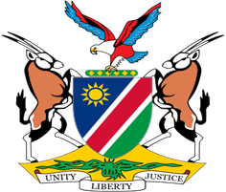

Statement by Jerry Mika, UPR of the Republic of Iceland, 25 January 2022

Thank you Mr. President,

Namibia warmly welcomes the esteemed delegation of Iceland and thank them for submitting a comprehensive national report which clearly sets out the measures taken by Iceland to improve the human rights of all persons on its territory since its last review.

We particularly commend Iceland for the measures taken to ensure equality between men and women in Icelandic society. In this regard we are pleased to note that Iceland has made further commitments through the adoption of the Gender Action Plan 2020-2023 to describe projects that will further increase gender equality.

While noting the progress made, we make the following recommendations for consideration by Iceland:

1. Ratify the Optional Protocol to the Convention on the Rights of Persons with Disabilities;

2. Withdraw all reservations to the International Covenant on Civil and Political Rights.

We wish the delegation of Iceland a successful review.

I thank you Mr. President.

