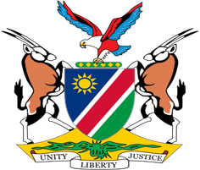

Statement by Tangi Shikongo, UPR of the Republic of Haiti, 31 January 2022

Thank you, Mr. President,

Namibia warmly welcomes the Esteemed Delegation of Haiti and thank them for their commitment to the UPR process.

Mr. President,

Climate Change continues to be the greatest threat to human rights all over world. In the case of Haiti we have witnessed over the years the devastating and negative impact of climate change on the enjoyment of human rights by all persons in Haiti. We call on States, especially the top global emitters, to do better because the survival of humanity is at stake.

Noting some of these challenges, in the spirit of constructive dialogue, Namibia makes the following recommendations for consideration by Haiti:

1. Develop a National Plan of Action to combat hate crimes, xenophobia, discrimination, and other related intolerances.

2. Accede to the Second Optional Protocol to the International Covenant on Civil and Political Rights aiming at the abolition of the death penalty

We wish the delegation of Haiti a successful review.

I thank you Mr. President.

