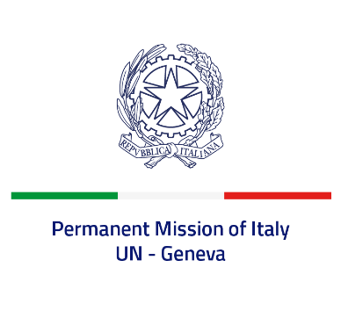
Check against delivery
UPR 40 - Zimbabwe
Wednesday 26 January 2022, 9:00 - 12:30

Delivered by: Ambassador Gian Lorenzo Cornado, Permanent Representative of Italy

(Focal point: Angela Zanca, First Secretary)

Thank you, Mister President.

We thank the distinguished delegation of Zimbabwe for their national report and presentation.

Italy notes the efforts carried out by Zimbabwe to implement the CRPD and welcomes the launch of the National Disability Policy.

Italy seizes this opportunity to offer Zimbabwe the following recommendations:

- Adhere to the UN Convention against Torture and Other Cruel, Inhuman or Degrading Treatment or Punishment and take all the necessary measures to ensure a safe environment to exercise the rights to peaceful assembly and freedom of expression;
- Decriminalise consensual adult same sex relations and combat all forms of discrimination and violence based on sexual orientation and gender identity;
- Take additional measures to prevent any form of violence and discrimination against women and girls, including harmful practices such as female genital mutilation and child, early and forced marriage;
- Adopt a de jure moratorium of capital executions with a view to fully abolish the death penalty and ratify the second optional protocol to the ICCPR.

We wish Zimbabwe a successful review.

I thank you.

