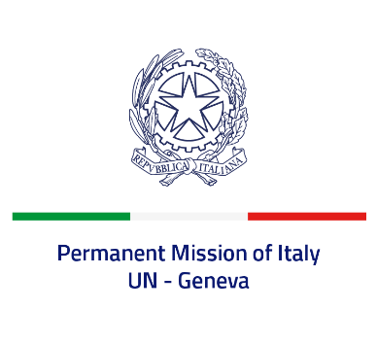
Check against delivery
UPR 40 - Uganda
Thursday 27 January 2022, 9:00 - 12:30

Delivered by: Ambassador Gian Lorenzo Cornado, Permanent Representative of Italy

(Focal point: Angela Zanca, First Secretary)

Thank you, Mister President.

We thank the distinguished delegation of Uganda for their national report and presentation.

Italy seizes this opportunity to offer Uganda the following recommendations:

- Create a safe environment to exercise the rights to peaceful assembly and freedom of expression, aligning the legislation to international law and prevent attacks and intimidation against human rights defenders, journalists and civil society actors;
- Enhance efforts to guarantee a proportionate use of force by security forces and to prevent torture and other ill treatments;
- Adopt a de jure moratorium of capital executions and ratify the Second Optional Protocol to the ICCPR, with a view to fully abolishing the death penalty;
- Take measures to combat all forms of violence and discrimination against women and children, including domestic violence, harmful practices, and child labour, and promote the full enjoyment of the right to education;
- Decriminalise consensual adult same sex relations.

We wish Uganda a successful review.

I thank you.

