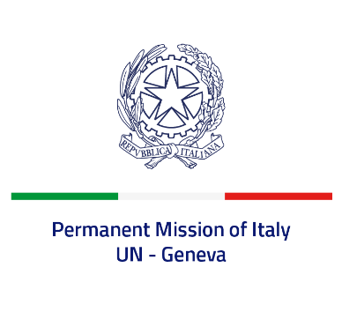
Check against delivery
UPR 40 - Togo
Monday 24 January 2022, 9:00 - 12:30

Delivered by: Ambassador Gian Lorenzo Cornado, Permanent Representative of Italy

(Focal point: Angela Zanca, First Secretary)

Thank you, Mister President.

We thank the distinguished delegation of Togo for their national report and presentation.

Italy commends Togo’s accession to the Second Optional Protocol to the ICCPR, as the final step in the abolition of death penalty in the Country. We also recognize the progress made by Togo to promote women’s empowerment and leadership, especially to increase their participation in political bodies.

Italy seizes this opportunity to offer Togo the following recommendations:

- Strengthen efforts to combat all form of discrimination and violence against women and girls, including domestic violence and harmful practices such as child, early and forced marriage and female genital mutilation;
- Take further measures to eradicate child labour;
- Decriminalise consensual adult same sex relations and combat discrimination based on sexual orientation and gender identity;
- Align legislation to the international standards regarding freedom of expression and peaceful assembly.

We wish Togo a successful review.

I thank you.

