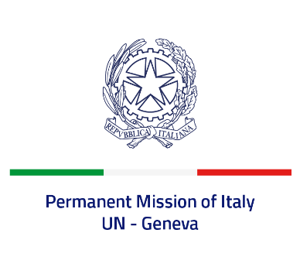
Check against delivery
UPR 40 - Timor-Leste
Thursday 27 January 2022, 14:30 - 18:00

Delivered by: Ambassador Gian Lorenzo Cornado, Permanent Representative of Italy

(Focal point: Angela Zanca, First Secretary)

Thank you, Mister President.

We thank the distinguished delegation of Timor-Leste for their national report and presentation.

Italy praises Timor-Leste for its efforts to implement the international human rights standards and welcomes its commitment on important human rights issues, such as the adoption of the National Action Plan Against Gender-Based Violence and the National Action Plan for Citizens with Disabilities.

We also appreciate the steps taken to prevent and combat human trafficking, in particular the approval in 2017 of the “Law on Preventing and Combatting Human Trafficking” which also ensures assistance and compensation for victims.

Italy seizes this opportunity to offer Timor-Leste the following recommendations:

- Ratify the Convention on the Rights of Persons with Disabilities and its Optional Protocol;
- Strengthen the ongoing efforts to prevent and combat violence and abuses against women and girls, including domestic violence and harmful practices, as child, early and forced marriage;
- Adopt measures to promote the full enjoyment of the rights of children and prohibit all forms of corporal punishment.

We wish Timor-Leste a successful review.

I thank you.

