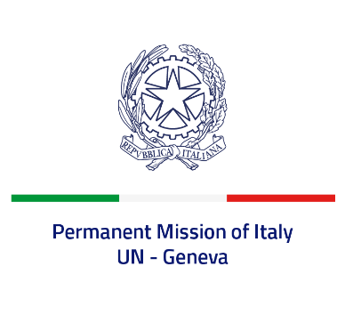
Check against delivery
UPR 40 – Syrian Arab Republic
Monday 24th January 2022, 14:30 – 18:00

Delivered by: Ambassador Gian Lorenzo Cornado, Permanent Representative of Italy

(Focal point: Daniele Borrelli, Counsellor)

Thank you, Mister President.

We thank the distinguished delegation of the Syrian Arab Republic for their national report and presentation.
Italy remains deeply concerned by all gross and systematic violations of human rights in the country and offers the following recommendations:
- Put an end to all acts of torture, enforced disappearances, extrajudicial executions as well as incommunicado detentions, and release activists and human rights defenders arbitrarily detained.
- Fully cooperate with the UN Commission of Inquiry and the International, Impartial and Independent Mechanism (IIIM) in order to ensure accountability for human rights violations and abuses.
- Grant safe and unhindered access to humanitarian organizations, cease all violations and abuses against civilians, in particular against children, end attacks against civilian facilities, including schools and hospitals.
- Empower women to meaningfully participate in decision-making processes at all levels, including peace talks.
- Consider establishing a formal moratorium on capital executions.
- Decriminalize consensual adult same sex relations.

We wish the Syrian Arab Republic a successful review.

I thank you.

