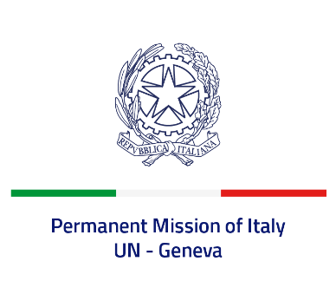
Check against delivery
UPR 40 – Sudan
Tuesday 1 February 2022, 9:00 – 12:30

Delivered by: Ambassador Gian Lorenzo Cornado, Permanent Representative of Italy

(Focal point: Daniele Borrelli, Counsellor)
Thank you, Mister President.

We thank the distinguished delegation of Sudan for their report and presentation.
Italy welcomes the recent ratification of the Convention against Torture and the Convention for the Protection of All Persons from Enforced Disappearance.

We would like to offer the following recommendations:

- Adopt a de jure moratorium of capital executions and ratify the Second Optional Protocol to the ICCPR.
- Take measures to prevent all forms of torture - including ratifying the OPCAT - as well as enforced disappearances, arbitrary detention and extrajudicial executions, and ensure accountability for all violations and abuses.
- Ratify the CEDAW and enhance efforts to combat discrimination and violence against women.
- Enhance efforts to guarantee the rights of the children and protect them from violence, abuse and involvement in armed conflict. Outlaw corporal punishments.
- Create a safer and enabling environment for increasing levels of freedom of expression, association and peaceful assembly and ensure accountability.
- Decriminalize consensual adult same sex relations.
We wish Sudan a successful review.
I thank you.

