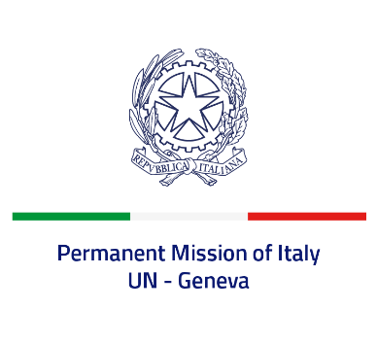
Check against delivery
UPR 40 – Republic of Moldova
Friday 28th January 2022, 9:00 – 12:30

Delivered by: Ambassador Gian Lorenzo Cornado, Permanent Representative of Italy

(Focal point: Daniele Borrelli, Counsellor)

Thank you, Mister President.

We thank the distinguished delegation of the Republic of Moldova for their national report and presentation.

Italy welcomes the commitment by the Republic of Moldova to promote and protect human rights, including through the adoption of the National Human Rights Action Plan for 2018-2022. We also welcome the ratification of the Council of Europe Convention on preventing and combating violence against women and domestic violence in 2021.
Italy seizes this opportunity to offer the Republic of Moldova the following recommendations:

- Finalize the internal procedures necessary to give full implementation to the Council of Europe Convention on preventing and combating violence against women and domestic violence.
- Continue the ongoing efforts to create a safe environment to exercise the right to freedom of expression and ensure media independence and pluralism.
- Continue the effort to prevent and counter violence and discrimination against LGBTIQ+ persons.
- Ratify the Optional Protocol to the Convention on the Rights of Persons with Disabilities signed in 2018.

We wish the Republic of Moldova a successful review.

I thank you.

