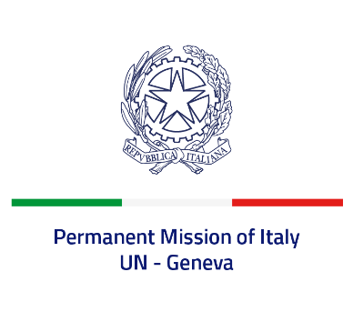
Check against delivery
UPR 40 – BOLIVARIAN REPUBLIC OF VENEZUELA
Tuesday 25th January 2022, 14:30 – 18:00

Delivered by: Ambassador Gian Lorenzo Cornado, Permanent Representative of Italy

(Focal point: Daniele Borrelli, Counsellor)
Thank you, Mister President.
We thank the distinguished delegation of the Bolivarian Republic of Venezuela for their report and presentation.

Italy welcomes and supports the OHCHR program to advance human rights in Venezuela.

Italy offers Venezuela the following recommendations:
- Stop all forms of torture, enforced disappearances, arbitrary detention and extrajudicial executions, duly investigate all alleged cases and ratify the Convention on Enforced Disappearance and the OPCAT.
- Guarantee freedom of expression and opinion on- and off-line and access to justice for victims of these violations, ensure that human rights defenders, journalists and humanitarian workers can operate in a safe environment.
- Facilitate a permanent presence of the OHCHR and allow access to the Independent International Fact-Finding Mission.
- Strengthen the independence and impartiality of the judiciary.
- Combat all forms of gender-based violence and discrimination.

We wish a successful review. I thank you.

