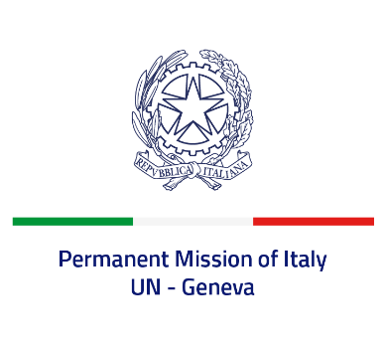
Check against delivery
UPR 40 – South Sudan
Monday 31st January 2022, 9:00 – 12:30

Delivered by: Ambassador Gian Lorenzo Cornado, Permanent Representative of Italy

(Focal point: Daniele Borrelli, Counsellor)

Thank you, Mister President.

We thank the distinguished delegation of South Sudan for their report and presentation.

Italy welcomes the action plan signed in 2020 between South Sudan and the United Nations to end and prevent all grave violations against children. We also welcome South Sudan’s commitment to the UPR process, including through the submission of a voluntary mid-term report.
Italy would like to offer the following recommendations:

- Adopt a de jure moratorium of capital executions and ratify the Second Optional Protocol to the ICCPR, with a view to fully abolishing the death penalty.
- Take measures to combat all forms of violence and discrimination against women, including sexual abuse and exploitation, and harmful practices, such as child early and forced marriage.
- Enhance efforts to guarantee the rights of the children and to protect them from violence, abuse and involvement in armed conflict, including recruitment and abduction.
- Decriminalize consensual adult same sex relations.
- Stop all forms of torture, enforced disappearances, arbitrary detention and extrajudicial executions, and ensure accountability for human rights violations and abuses.

We wish South Sudan a successful review.

I thank you.

