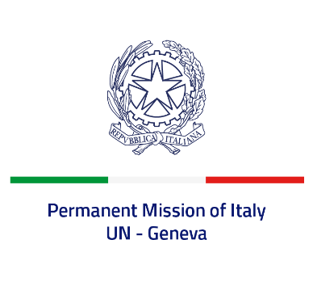
Check against delivery
UPR 40 – Lithuania
Wednesday 26th January 2022, 14:30 – 18:00

Delivered by: Ambassador Gian Lorenzo Cornado, Permanent Representative of Italy

(Focal point: Daniele Borrelli, Counsellor)

Thank you, Mister President.

We thank the distinguished delegation of Lithuania for their national report and presentation.

Italy congratulates Lithuania on the election in the Human Rights Council for the term 2022-2024 and welcomes the adoption of several action plans for the promotion and protection of human rights since the last UPR review, including the Action Plan for the promotion of non-discrimination and the Action Plan for combating trafficking in human beings.
Italy seizes this opportunity to offer Lithuania the following recommendations:

- Ratify the Council of Europe Convention on Preventing and Combating Violence against Women and Domestic Violence and increase the efforts to support and protect women survivors of gender-based violence, including domestic violence.
- Ratify the Optional Protocol to the Convention on the Rights of the Child on a communications procedure.
- Continue to enhance the legal framework for the protection of the rights of persons in vulnerable situations, including those belonging to ethnic minorities.

We wish Lithuania a successful review.

I thank you.

