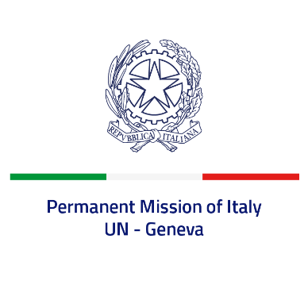
Check against delivery
UPR 40 - Iceland
Tuesday 25 January 2022, 9:00 - 12:30

Delivered by: Ambassador Gian Lorenzo Cornado, Permanent Representative of Italy

(Focal point: Angela Zanca, First Secretary)

Thank you, Mister President.

We thank the distinguished delegation of Iceland for their national report and presentation.

Italy commends Iceland’s commitment to the UPR and the steps taken since its last review, in particular the ratification of the Council of Europe Convention on Preventing and Combating Violence against Women and Domestic Violence, as well as the ratification of the Optional Protocol to the UN Convention Against Torture.

We also praise Iceland for the measures adopted to promote the rights of LGBTIQ+ persons and to increase protection of the freedom of expression, media and information.

Italy seizes this opportunity to offer Iceland the following recommendations:

- Conclude the procedures to ratify the Convention for the Protection of all Persons from Enforced Disappearance, signed in 2008;
- Adhere to the Optional Protocol to the Convention on the Rights of the Child on a communications procedure;
- Continue the ongoing efforts to prevent trafficking in human beings.

We wish Iceland a successful review.

I thank you.

