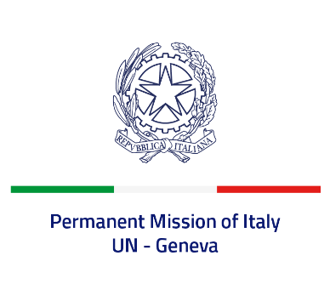
Check against delivery
UPR 40 - Haiti
Monday 31 January 2022, 14:30 - 18:00

Delivered by: Ambassador Gian Lorenzo Cornado, Permanent Representative of Italy

(Focal point: Angela Zanca, First Secretary)

Thank you, Mister President.

We thank the distinguished delegation of Haiti for their national report and presentation.

Italy notes the adoption of an “Education and Training Plan 2020-2030” aimed at guaranteeing free primary and secondary education for all.

We recognize that Haiti had to confront with dramatic events last year, including the assassination of President Moïse and the August 2021 earthquake.

Nonetheless, Italy is concerned with the deterioration of the human rights situation in Haiti, as highlighted by the Secretary General and the OHCHR in their reports, and seizes this opportunity to offer the following recommendations:

- Continue the process of ratification of the main international human rights instruments, including the Optional Protocols to the ICCPR;
- Ratify the Convention against Torture and Other Cruel, Inhuman or Degrading Treatment or Punishment, signed in 2013, and enhance efforts to guarantee a proportionate use of force by security forces, to prevent torture and other ill treatments and to ensure accountability;
- Adopt measures to promote the full enjoyment of the rights of children, including the right to education, and combat child labour;
- Adopt measures to prevent sexual and gender-based violence, including domestic violence and abuses.

We wish Haiti a successful review.

I thank you.

