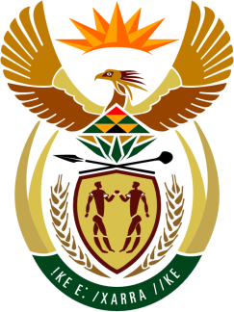

SOUTH AFRICAN PERMANENT MISSION

40th SESSION OF THE WORKING GROUP ON THE
UNIVERSAL PERIODIC REVIEW

Review of SUDAN

1 FeBRUARY 2022
(09:00-12:30)

VIRTUAL (ZOOM PLATFORM)

Check against delivery
(1min.05 seconds)

Mister President,

South Africa welcomes the distinguished delegation of Sudan to this UPR Session.

My delegation welcomes the ratifying of the Convention against Torture and Other Cruel, Inhuman or Degrading Treatment or Punishment (CAT of 1984), and the International Convention for the Protection of All Persons from Enforced Disappearance (ICPPED of 2006), ratified by Sudan in 2021.

In order to ensure progress in promoting and protecting human rights, South Africa wishes to respectively recommend that Sudan:

- Continue to strengthen measures in combating violence against women and girls and provide legal protection for victims of sexual and gender-based violence

- Review article 3 of the Persons with Disabilities Act of 2017 to explicitly prohibit discrimination on the basis of disability and to ensure that denial of reasonable accommodation was recognized as a form of disability-based discrimination. It also recommended including those provisions in the forthcoming draft Constitution, so as to provide the highest legal protection against disability-based discrimination and multiple and intersectional forms of discrimination faced by persons with disabilities.

South Africa wishes Sudan a successful review.

I thank you.

